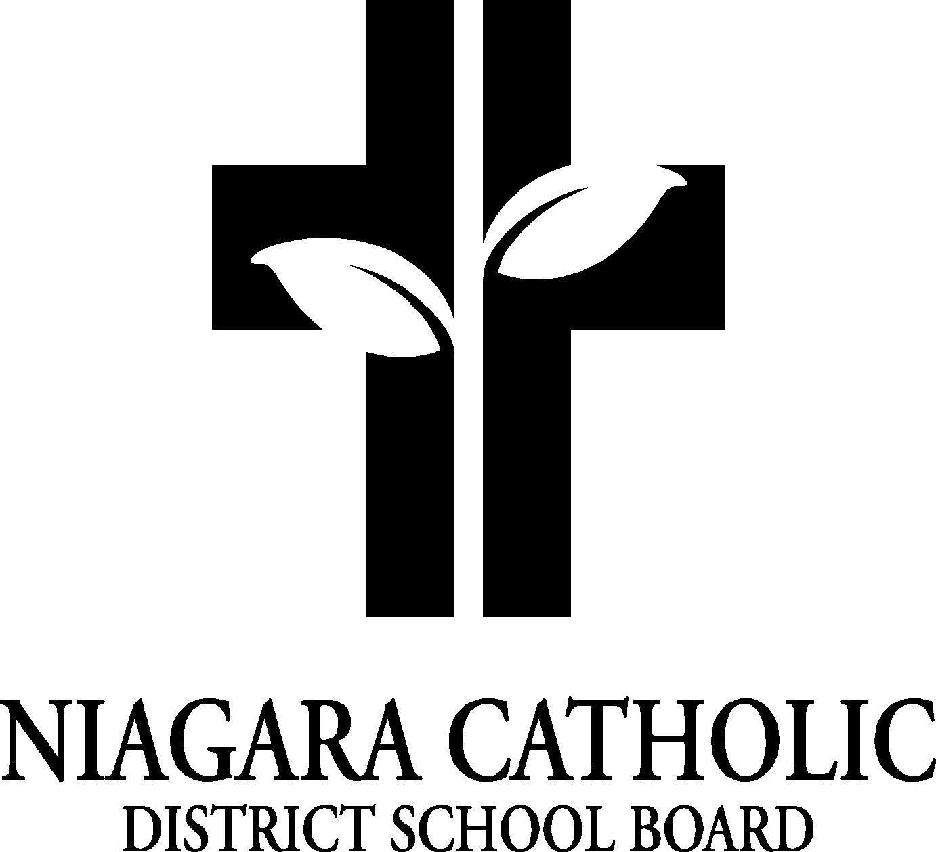

1AGENDA
NAME OF SCHOOL
CATHOLIC SCHOOL COUNCIL MEETING

DATE
Location

- ROUTINE MATTERS
- Opening Prayer
- Roll Call
- Approval of Agenda
- Elections of Chair and/or Co-Chairs (when applicable)
- Election of the Ontario Association for Parents in Catholic Education (OAPCE) (when applicable)
- Disclosure of Conflict of Interest
- Approval of the Meeting Minutes of the Name of School, Catholic School Council Meeting of insert date.

- PRESENTATIONS

- POLICIES FOR VETTING-FEEDBACK

- PRINCIPAL’S REPORT
- Niagara Catholic Parent Involvement Committee Report
- Special Education Advisory Committee (SEAC) Report
- Catholic School Council Financial Report

- OAPCE REPORT

- STAFF REPORT

- AGENDA ITEMS-DISCUSSION FOR FUTURE MEETINGS

- NEXT MEETING

- CLOSING PRAYER

- ADJOURNMENT

